SIT123: Data Capture Technologies

# Lab Work Week 6:

# Test Motion Sensors for Range and FoV (30 marks)

Today, there are many cheap sensors available on the market, such as passive

Infra-Red (PIR) motion sensors. However, a drawback of these sensors is the inconsistency of their output depending on the manufacturer, and also how they perform differently under various environmental conditions.

## Due Date Friday 8:00pm, 9th September 2022

## Hardware Required

* Arduino Board
* USB cable
* HCSR505 PIR (Passive Infra Red) Motion Detector
* Bring your laptop with Arduino IDE installed
* A measuring tape
* A protractor

## Software Required

* Arduino IDE

## Pre-requisites: You must do the following before this task

1. **Attend Class (Lecture)**
2. **Read this sheet from top to bottom**

## Task Overview

In this task, you will test the PIR Motion sensor for range and FOV (field of view) and calculate its TPR (true positive rate).

## Task Submission Details

There are 6 questions in this task. Answer all of them in this word document itself and submit to unit site.

Steps:

1. Find some open floor space indoors (around 3 m wide and 1.5 m in height) and mark the floor area as given in the diagram below:

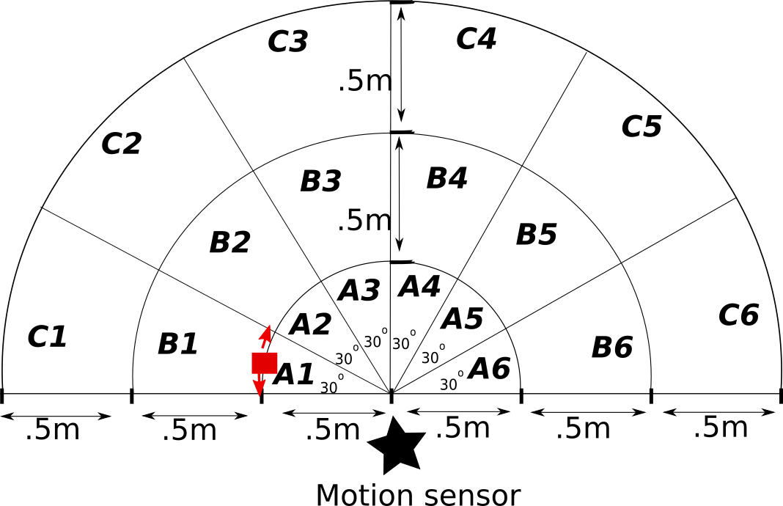

1. Attach the motion sensor to your Arduino board. You can refer to the Task 2.2P instructions on how to do this.
2. Place the motion sensor connected to your computer at the center as indicated in the diagram.

### **Q1. Recording Active/Inactive States**

We want to find out if the motion sensor can detect movement in each section A1 to A6, B1 to B6 and C1-C6.

* Open the code for motion sensor used in Task 2.2P in your Arduino IDE.
* Ask a friend to step into the edge of section A1 (the red square in the given image) and step sideways bit (look at the red arrows), being careful to stay within the boundaries of A1.
* Check the Serial monitor to see if ‘Active’ states are being recorded. If you can see Active states, mark that in the table below, and then ask your friend to move the next section A2.
* If you can see ‘active’ states when they move to A2, ask your friend to be still for a few seconds until you start seeing ‘Inactive’ states again on the serial monitor, and then ask the friend to step forwards and backwards a bit, being careful to stay within the boundaries of A2. Mark what you see in the table below.
* Repeat this for sections A1 to A6, B1 to B6 and C1-C6.

|  |  |  |  |
| --- | --- | --- | --- |
|  | A | B | C |
| 1 | Active | Active | Inactive |
| 2 | Active | Active | Active |
| 3 | Active | Active | Active |
| 4 | Active | Active | Active |
| 5 | Active | Inactive | Inactive |
| 6 | Active | Inactive | Active |

(5 marks)

### **Q2. Calculate the True Positive Rate at .5 m Range**

1. Enter the motion data you recorded from A1 to A6 in shared file

<https://docs.google.com/spreadsheets/d/1e3n6oo4L-dc3kydQDnt3OX8wOU6hed8v_XALm0Xo3LI/edit?usp=sharing>

If you did the data collection as a group, only enter one reading per group, with all of your names in the relevant cell. Copy the table from the shared file and include here, once there are results from at least 8 groups.

b) Use the results from at least 8 groups to calculate the true positive rates for the FoVs given in the table below. You must show the steps of your calculations in the table.

|  |  |
| --- | --- |
| FoV | True positive rate |
| 180° | 3/3 = 1*100 =100% |
| 120° | 3/3 = 1*100 =100% |
| 60° | 3/3 = 1*100 =100% |

(5 marks)

### **Q3. Calculate the True Positive Rate at 1 m Range**

1. Enter the motion data you recorded from B1 to B6 in shared file <https://docs.google.com/spreadsheets/d/1e3n6oo4L-dc3kydQDnt3OX8wOU6hed8v_XALm0Xo3LI/edit?usp=sharing>

If you did the data collection as a group, only enter one reading per group, with all of your names in the relevant cell. Copy the table from the shared file and include here once there are results from at least 8 groups.

b) Use the results from at least 8 groups to calculate the true positive rates for the FoVs given in the table below. You must show the steps of your calculations in the table.

|  |  |
| --- | --- |
| FoV | True positive rate |
| 180° | 1/(1+2) = 0.3333*100 =33.33% |
| 120° | (1+1)/(1+2) =0.6667*100 =66.67% |
| 60° | 3/3 = 1*100 =100% |

(5 marks)

### **Q4. Calculate the True Positive Rate at 1.5 m Range**

1. Enter the motion data you recorded from C1 to C6 in shared file <https://docs.google.com/spreadsheets/d/1e3n6oo4L-dc3kydQDnt3OX8wOU6hed8v_XALm0Xo3LI/edit?usp=sharing>

If you did the data collection as a group, only enter one reading per group, with all of your names in the relevant cell. Copy the table from the shared file and include here once there are results from at least 8 groups.

b) Use the results from at least 8 groups to calculate the true positive rates for the FoVs given in the table below. You must show the steps of your calculations in the table.

|  |  |
| --- | --- |
| FoV | True positive rate |
| 180° | 1/(1+2) = 0.3333*100 =33.33% |
| 120° | (1+1)/(1+2) = 0.6667*100 =66.67% |
| 60° | 3/3 = 1*100 =100% |

(5 marks)

### **Q5. Based on the above, what can you say about the range and FoV of the motion sensor tested? Justify your answer, giving reasons.**

(5 marks)

With the setup described above, sensors were able to detect movement across all segments of A at a distance of 0.5 m and a field of view of 180 degrees (A1 to A6). All points of view in Section A were considered "Active" readings. Each field of view (FOV) has a 100% true positive rate at a distance of 0.5m. At 1m and 180 degrees FOV, the sensor read "Active" for B1 through B4 but "Inactive" for B5 and B6. 1m away with 120 degrees of field of view, the sensors read "Active" for B2 through B4 but "Inactive" for B5. Further, both B3 and B4 were "Active" when the FOV was set to 60 degrees and the distance was 1 metre. At a distance of 1.5 m and a field of view of 180 degrees, the sensors registered "Inactive" for C1 and C5 and "Active" for C2, C3, FOV4, and C6. While the sensors identified "Active" for C2 through C4 and "Inactive" for C5 at a field of view (FOV) of 120 degrees and a distance of 1.5 metres, they detected "Active" for C3 and C4 at a FOV of 60 degrees and a distance of 1.5 metres. In conclusion, the sensor's accuracy degrades with increasing range.

### **Q6. Propose an experiment to find the True Negative Rate (TNR) of this sensor.**

(5 marks)

A experiment that is aimed to determine whether or not motion can be detected in a location where none should exist, such as a glass case that contains the coffin of a famous person who has just passed away and is on display. Readings taken by the sensor between the hours of 12 p.m. and 12 a.m. may tell us a lot about the true negative rate that has been there during the whole time. During this experiment, the 'Inactive' value will behave as the True Negative, while the 'Active' value will act as the 'False Positive.'